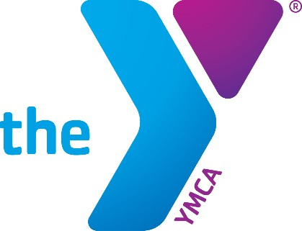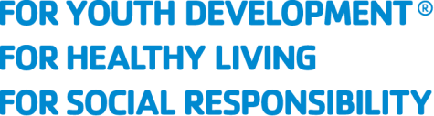

SIGN UP FOR
A YMCA ACCOUNT AND LINK ACCESS
YMCA OF THE USA

REVISED DECEMBER 2020

CONTENTS
Sign Up for a New YMCA Account 3
Request Link Access 9
Forgot Your Password 12
Forgot Your Registered Email 15

Sign Up for a New YMCA Account
Your YMCA Account is the first step in gaining access to applications provided by YMCA of the USA (Y-USA) including the Brand Resource Center, Learning and Career Development Center, Link, and Manage Our Y Profile and the among others. Anyone can create a YMCA Account using any email address.

Note: If you have an existing YMCA Account and/or are transferring from a local YMCA, please contact us at 800.872.9622 or fulfillment@ymca.net

- Go to the Sign In To My YMCA Account page via https://services.ymca.net and click the Sign up now button. The Register A New YMCA Account page opens.
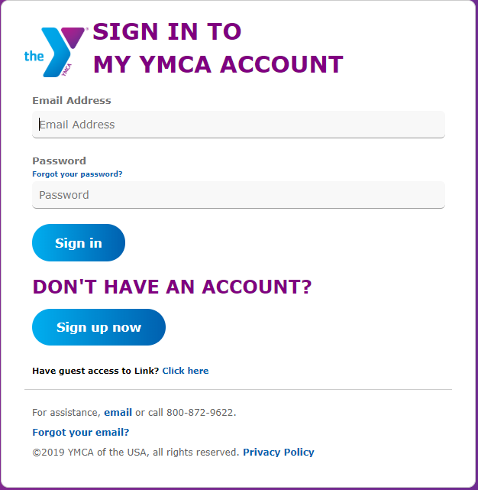

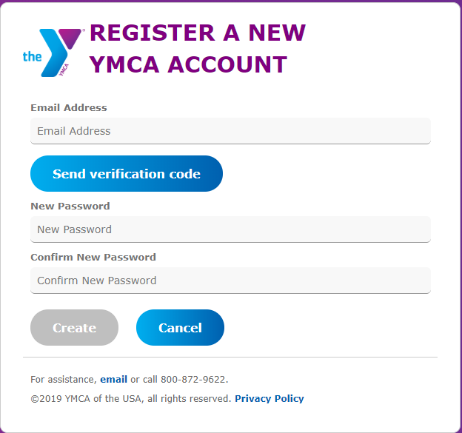
- Enter the email address you will use to log in, and then click the Send Verification Code.

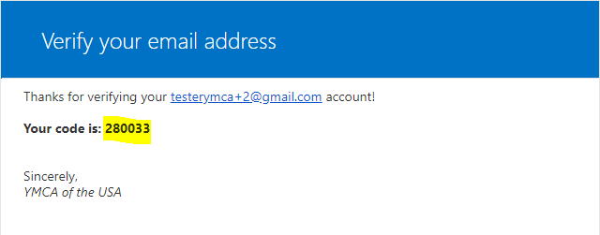
- You will be sent a verification code to your email inbox.

- Enter the code in the Verification code field and click the Verify Code button.
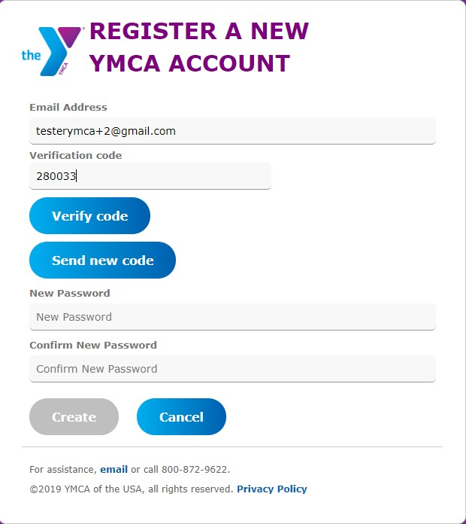
Note: The verification code is only good for 5 minutes. If you wait longer than 5 minutes to enter the code, a new code must be requested using the Send New Code button.

- After the code is accepted, entera a password and click Create. The password must be 8-16 characters, containing 3 out of 4 of the following:
- Lowercase characters
- Uppercase characters
- Digits: 0 - 9
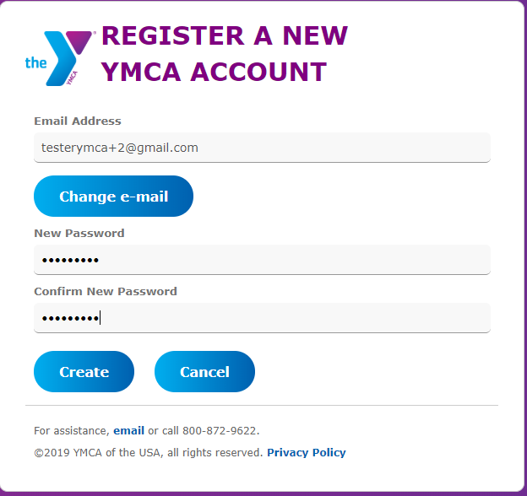
- Symbols: @ # $ % ^ & * - _ + = [ ] { } | \ : , ?/`~ " ( ) ;

- The What's Your Name? page opens. Enter your first and last name, then click the Continue.
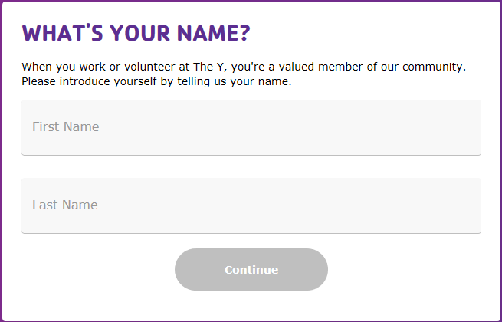

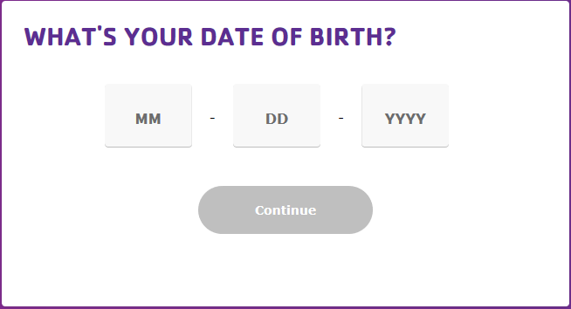
- The What's Your Date of Birth? page opens. Enter you Date of Birth, then click the Continue.

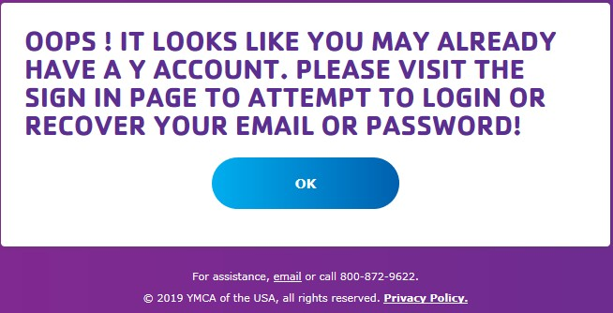
Note: If First Name, Last Name and Date of Birth entered matches with an already existing account the following screen appears. Click OK to return to Sign in to My YMCA Account page.

- What Gender Do you Identify As? page opens. Select your response, then click the Continue.
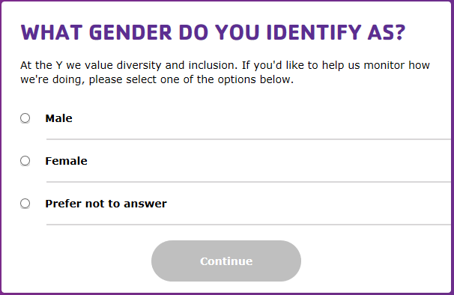

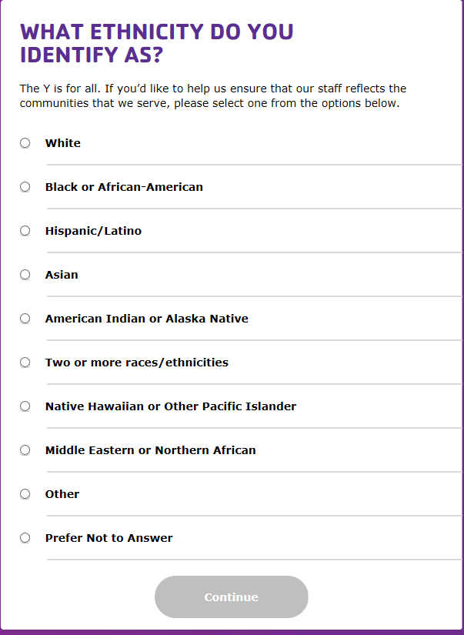
- The What Ethnicity Do You Identify As? page opens. Select your response, then click the Continue.

- The What Is Your Connection to the Y? page opens. Select your response, then click the Continue.
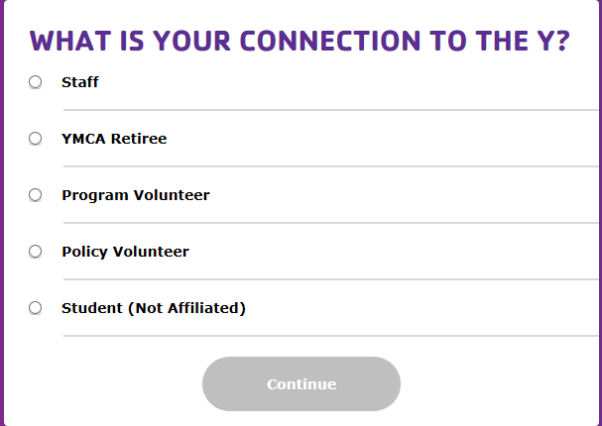

- If Staff, YMCA Retiree, Program Volunteer or Policy Volunteer is chosen then the Which Y Facility Are You Affiliated with? page opens. If Student is chosen advance to step 17.

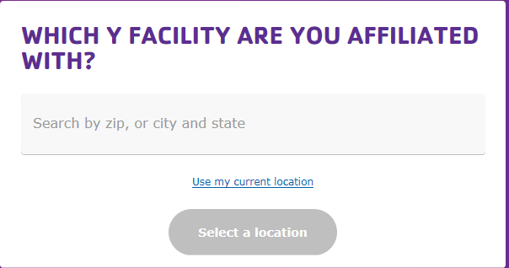

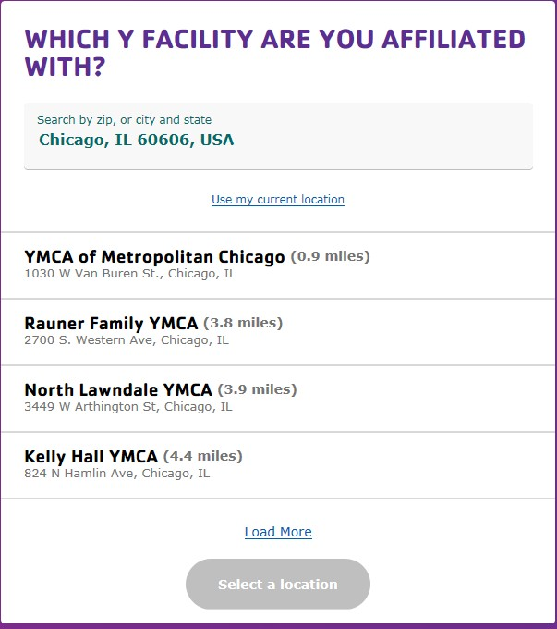
- Enter the Zip or City and State of the Y you are Affiliated with. Select your response from the answer that populates in the dropdown. YMCAs will be displayed. If your Y does not appear click on Load More.

- Click on the Y that you are affiliated with. A Google Map box will appear. Click the Continue button.

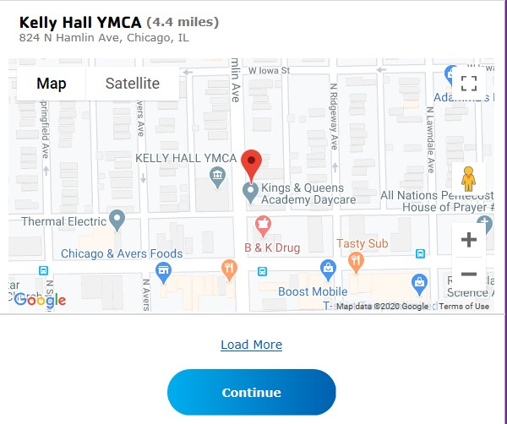

- The Last Step! page opens. Review all your information. Click Edit next to any field that you need to change or click Confirm.
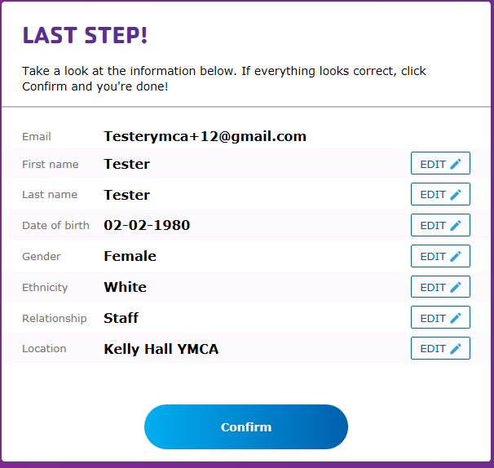

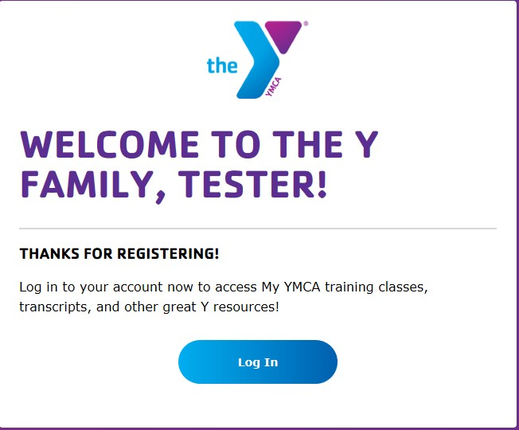
The confirmation dialog appears.

Request Link Access
- Enter your email address and password, then click the Sign In button.
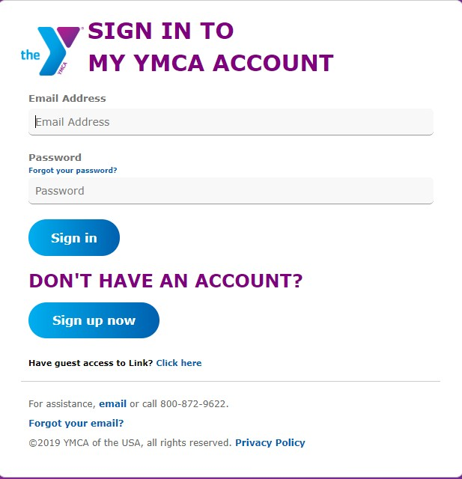
If your account is affiliated with a Y and you’ve been approved for Link access, the Link home page will open.
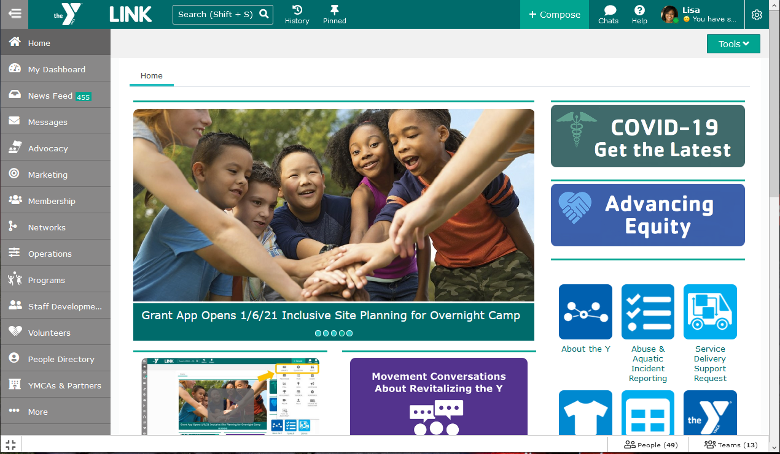

- If you are not approved, you will see the Welcome page. Click the Request access to Link.

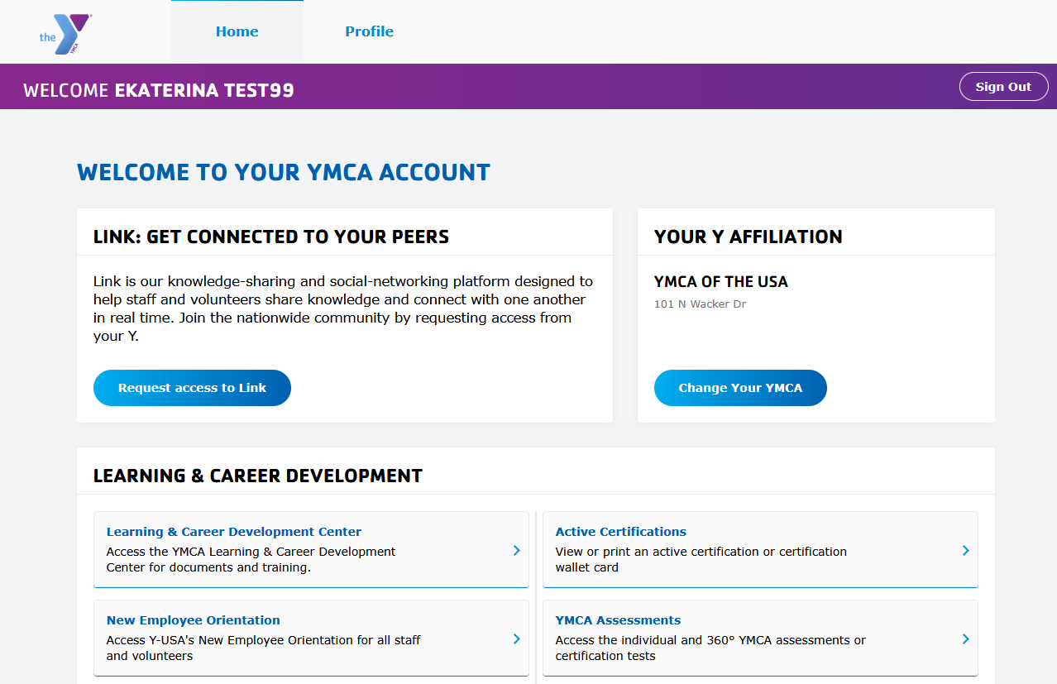

- On the Request Access to Link page., confirm your YMCA and select your role. Add an optional note, e.g., “I am a new hire reporting to <name>.” Click Request access.
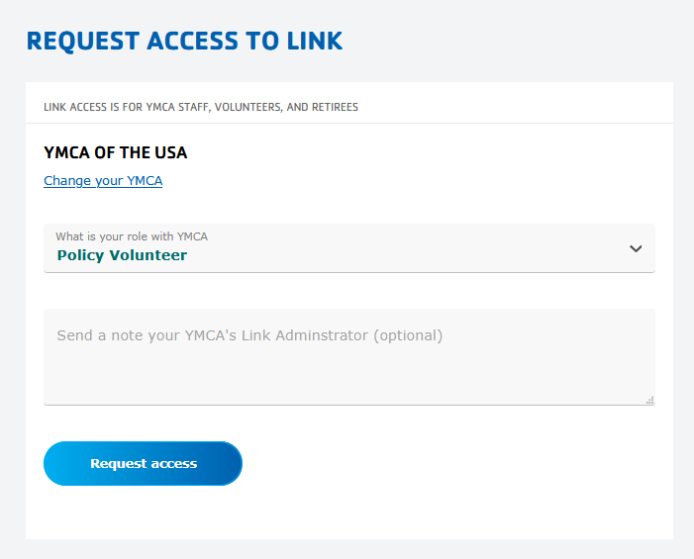

- Read the User Access Request Disclaimer and click I agree and want access.

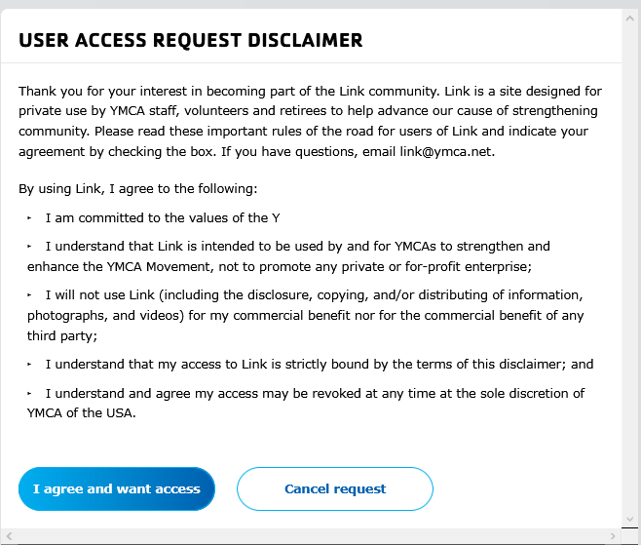

On the Welcome page, your request will show as pending. The Link Administrator at your YMCA is responsible for reviewing and approving your request.

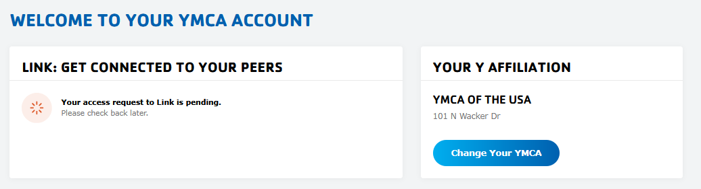

Forgot Your Password
- Go to the Sign In To My YMCA Account page via https://services.ymca.net. Click the Forgot your password? link.
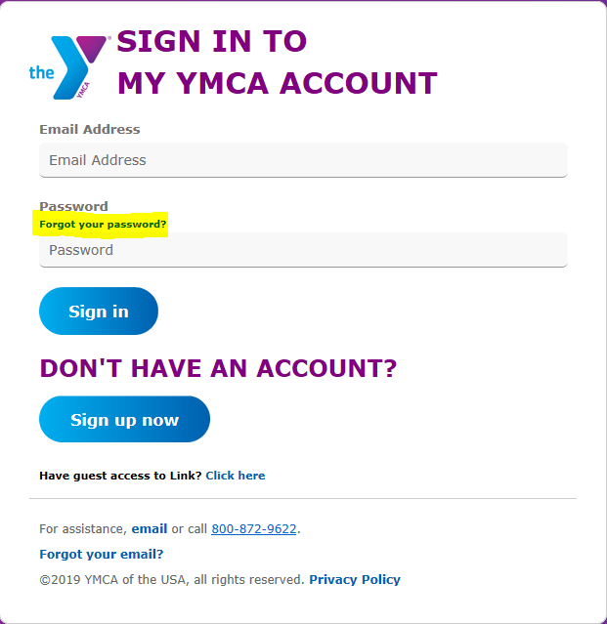

- Change your YMCA Account Password page opens. Enter the email address associated with your account and click the Send Verification Code button.

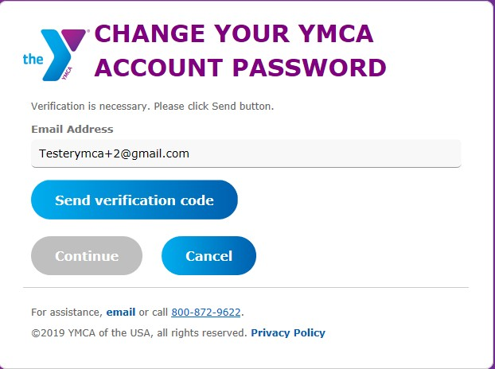

- You will be sent a verification code to your email inbox.

- Enter the code in the Verification code field and click the Verify Code button.
Note: The verification code is only good for 5 minutes. If you wait longer than 5 minutes to enter the code, a new code must be requested using the Send New Code button.

- The Change Your YMCA Account Password page opens. Click Continue to change password. Ignore the Change e-mail button.
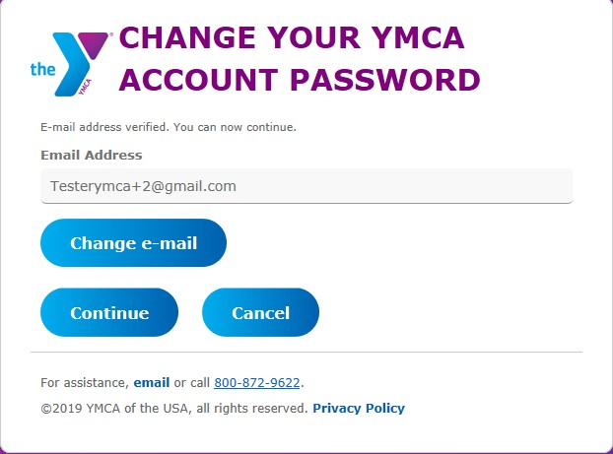

- The Change Your YMCA Account Password page opens. Enter a new password in the password fields and click the Continue button. The password must be 8-16 characters, containing 3 out of 4 of the following:
- Lowercase characters
- Uppercase characters
- Digits: 0 - 9
- Symbols: @ # $ % ^ & * - _ + = [ ] { } | \ : , ?/`~ " ( ) ;
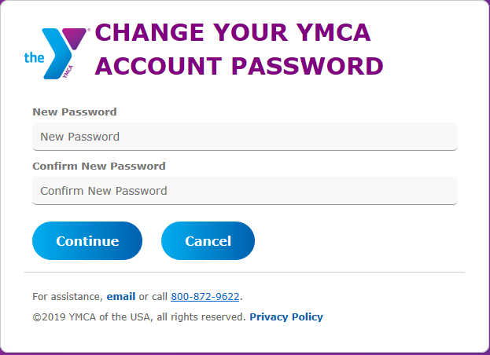

Forgot Your Registered Email
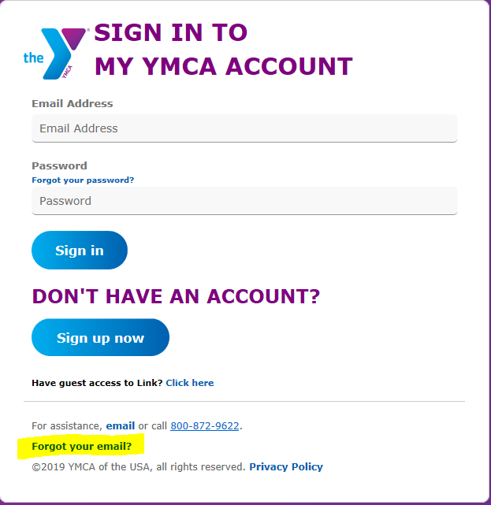
- Go to the Sign In To My YMCA page via https://services.ymca.net and click the Forgot your email? link. The Retrieve Your YMCA Account Email page opens.
- Enter the personal information associated with your account and click the Retrieve Email button.

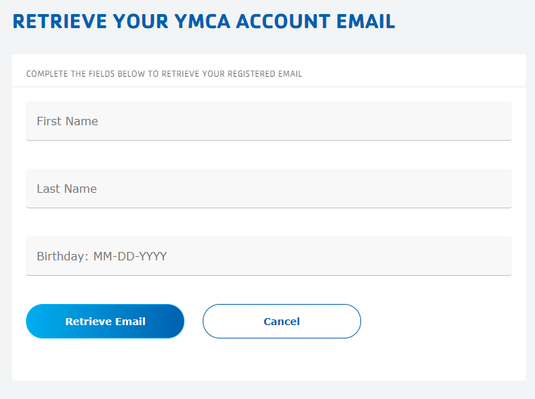

- If system finds a match, the Your YMCA Account Email Is: page will display. User can click here to sign in now to return to the Sign in to My YMCA Account page and login.
