YMCA National Youth Event Volunteer Registration System
Step by Step Instructions with Screenshots

- Use a PC, rather than a tablet or mobile device.

- Clear your cache / browsing history.

- Make sure you have a YMCA account. If you have ever taken a YMCA training course (such as YMCA Swim Officials training) or been a YMCA employee, you have an account. If you have ever accessed the YMCA’s Learning and Career Development Center (LCDC), you have an account.
- If you do not have an account, create one (instructions here) and remember your exact name, e-mail address and password used to create it. Each person must use their own e-mail address. Two people cannot share the same e-mail address.
- If you just created a new YMCA account, close out of that site before going to the next step.

- Go to https://datacollectionhub.ymca.net/

- Click Get Started
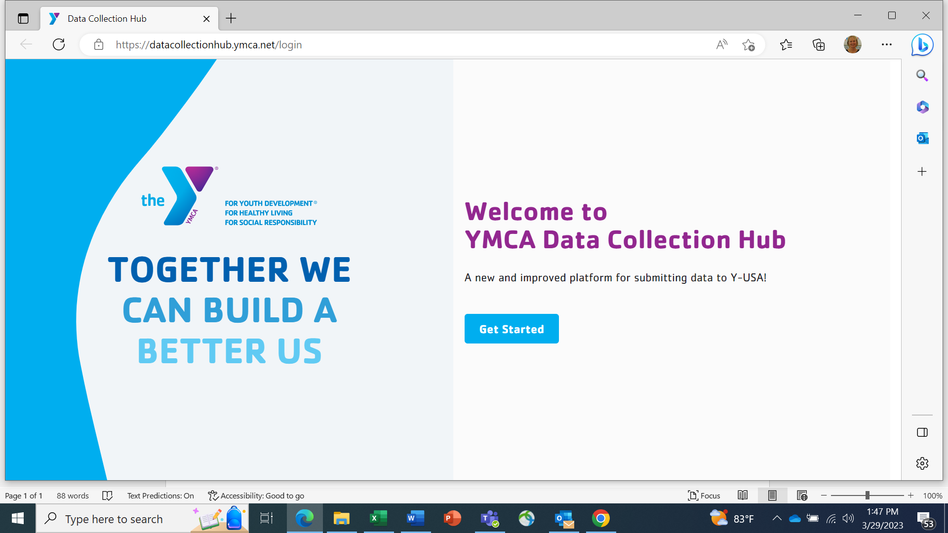

You will be asked to sign into your YMCA account. If you have had an account and used that on your current computer, it may self-populate.

- Do not click on any prompts on the left under Quick Information.
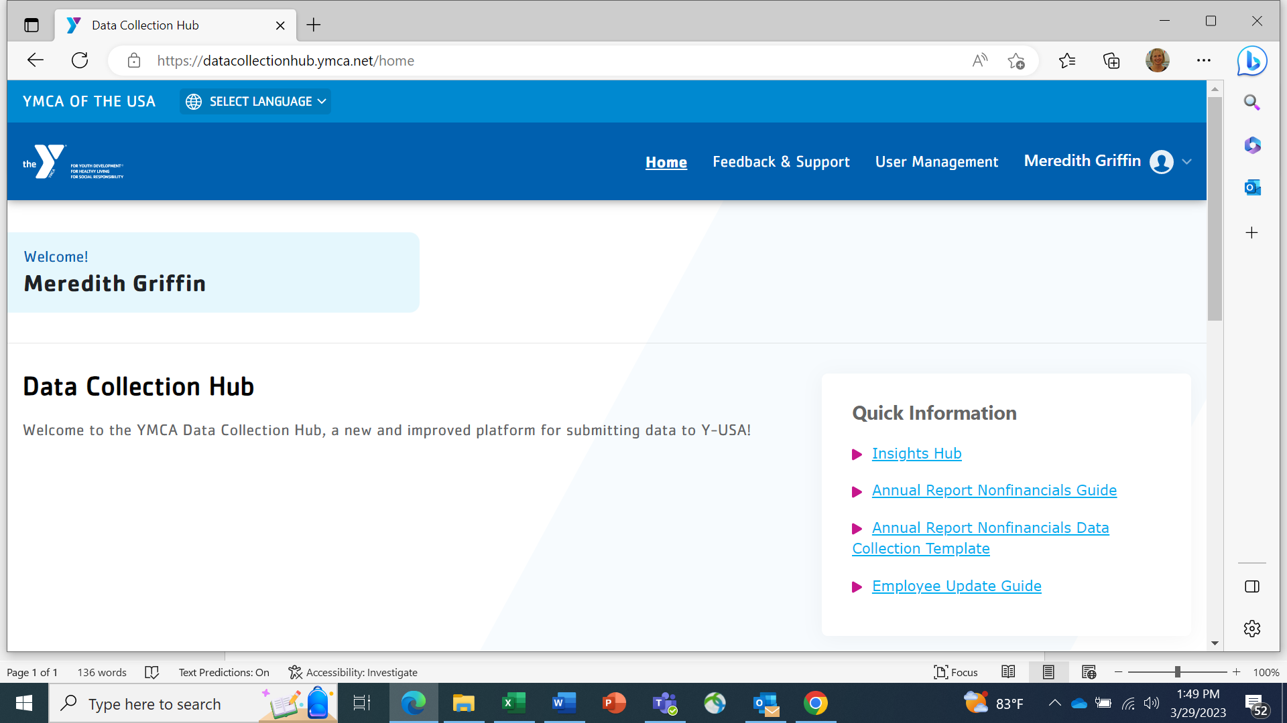

- Scroll down until you see the Volunteer Registration box. Click on that box.
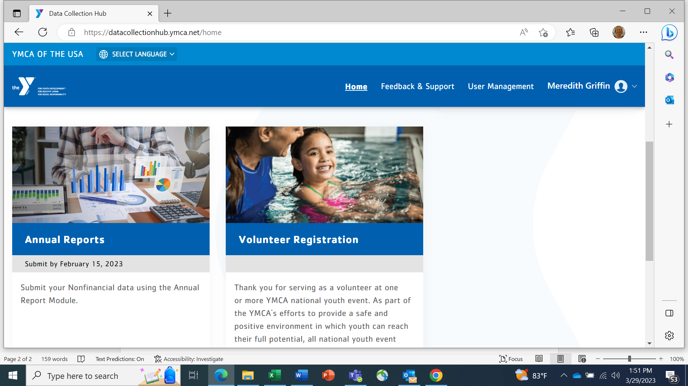

- Your personal details (name, address, phone, etc.) will appear. Scroll down to see where to upload your documents.

- Remember to click Submit on the bottom of the screen when you finish.

Important Notes
- Do not create another YMCA account if you already have one. Contact fulfillment@ymca.net for assistance with your existing account.
- You must be added to the access list in the system so if you enter your correct information and get a message that you do not have access, e-mail Meredith Griffin with the name and e-mail address on your YMCA account.
- You cannot share an e-mail address with another person
- Your name and e-mail address in the Data Collection Hub (volunteer registration system) must be exactly the same as your YMCA account.
- If you share a computer with someone else who is trying to register in the system, it is especially important to exit the system and clear your cache before changing users.

